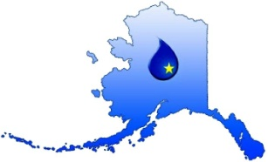
Alaska Rural Water Association
2015 Annual Training Conference
Speaker Biography and Training Narrative

This form is required for ADEC course approval and CEU assignment.
Use one form for each class being submitted for approval.

Speaker Name:
Company Name:
Address:
Address Line 2:
City: | State: |  | ZIP:
Phone: |  | Fax:
Email: |  | Cell:
Speaker Biography: (Brief description, 4-6 sentences.)
Class Title:
Class Length (Hours): 1 2 3 4 5 6 7 8
Training Track: Water Wastewater Source Water/Regulatory/Engineering
Brief Description:
*** For Office Use Only ***
CEUs Assigned:__________ Core DW Core Non-Core None

